Adam Gincel

CS442 HW 1

*I pledge my honor that I have abided by the Stevens Honor System.*

Question 1:

a) 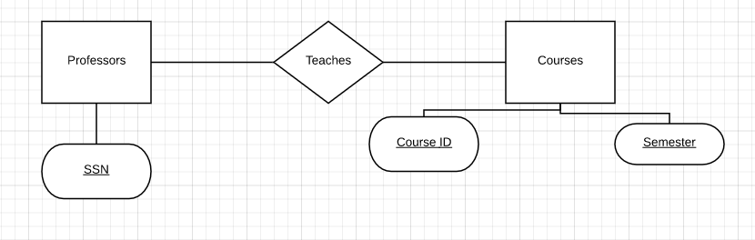

Candidate key: (Professor: SSN, Courses: Course ID, Courses: Semester)

b)

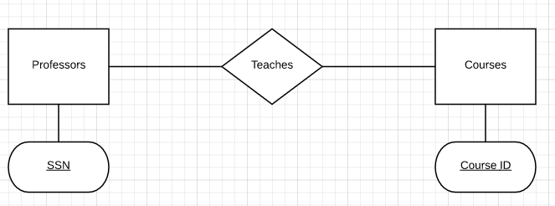

Candidate Key: (Professor: SSN, Courses: Course ID) – if only the most recent class listing needs to be recorded, we no longer need a primary key Semester.

c)

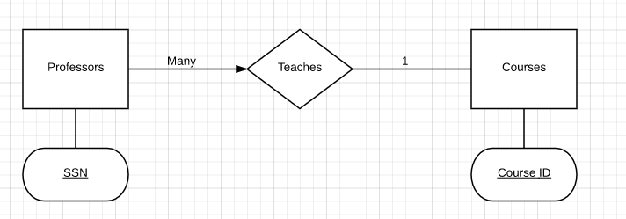

d)

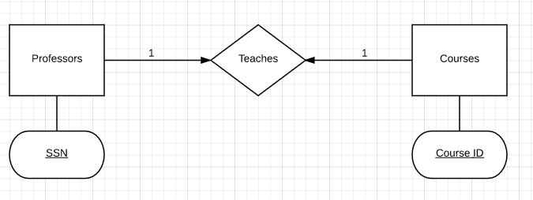

Question 2

1. 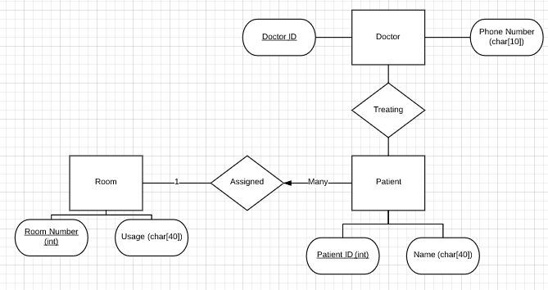

Assigned(PatientID, RoomNumber)

CREATE TABLE Assigned {

RoomNumber INTEGER,

PatientID INTEGER,

PRIMARY KEY (PatientID),

FOREIGN KEY (PatientID)

REFERENCES Patient(PatientID),

FOREIGN KEY (RoomNumber)

REFERENCES Room(RoomNumber)

}

Treating(PatientID, DoctorID)

CREATE TABLE Treating {

PatientID INTEGER,

DoctorID INTEGER,

PRIMARY KEY (PatientID, DoctorID),

FOREIGN KEY (PatientID)

REFERENCES Patient(PatientID),

FOREIGN KEY (DoctorID)

REFERENCES Doctor(DoctorID)

}